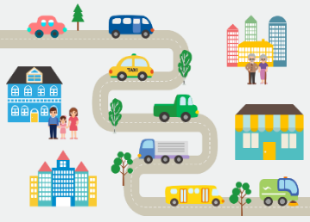
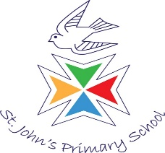
Focus areas of learning: Understanding of the world: we will be exploring different forces (push/pull) and floating and sinking. We will also be looking at different transport now and in the past.
Literacy: we will be creating our own narratives and imagining what might happen next in a story we have heard.
Expressive arts and design: we will be creating our own weather music based on the sounds of storms and rain.
Key dates

6th May: Trip to the Watercress line
22nd May: Sports day

Year R
Summer 1 2026
Transport and Journeys!
Suggested additional reading:
‘Mr Gumpy’s Motor Car’ by John Burningham
‘Amazing Machines’ series of books by Tony Mitton
‘Mrs Armitage, Queen of the Road’ by Quentin Blake
What can you do at home?
- Point out and talk about different modes of transport you see when out and about. How many buses can you see? Where are they going?
- Go on a bus journey and talk about the different things that you see.
- Talk about floating and sinking when playing with water or having a bath!
In this theme, we will be learning about different methods of transport through our key texts. We will also be thinking about different journeys that people go on and how they travel.

