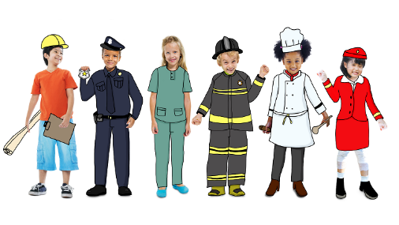
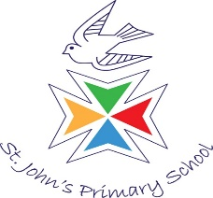
Key dates
19th January: class photos.
5th February: local area walk to draw maps and post letters.
Focus areas of learning:
Understanding the world: we will be talking about the different jobs that people do in our community.
Expressive arts: we will be developing our drawing skills in the classroom and in the woodlands.
Communication and Language: we will be developing our own stories and narratives through role-play.
In this theme, we will be learning about the different kinds of people that help us in our community. We will be applying our new knowledge in role-play to develop our key skills.

What can you do at home?
- Give children opportunities to mark make in purposeful contexts (e.g. writing a shopping list or a menu for dinner).
- Talk about the different people that help us and the jobs that they do.
- Talk about the different ways that we can stay healthy and safe.
Further reading:
‘Cops and Robbers’ by Janet and Alan Ahlberg
‘Dig, dig, digging’ by Margaret Mayo and Alex Ayliffe
Year R
Spring 1 2026
People who help us

