St John's Church of England Primary School
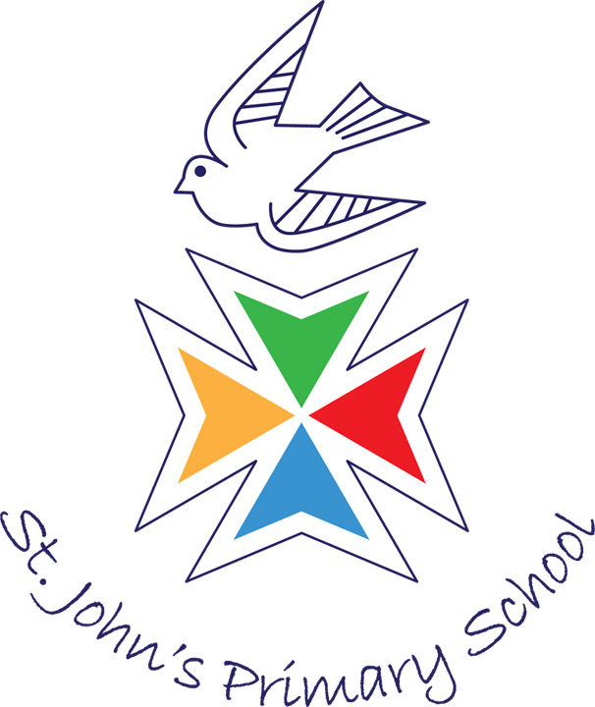
Kingsmill Road, Basingstoke RG21 3JU
Telephone: (01256) 324121
E-mail: adminoffice@st-johnscofe.hants.sch.uk

Headteacher: Mrs A Nicholls
Deputy Head: Mrs A Wynn
Senior Admin Officer: Mrs C Barker

Wednesday 11th June 2025

Parents of Children in Year 5 and 6
Dear Parents,

As part of the Year 5 and 6 PSHE programme of work this term, their curriculum learning will include Sex and Relationships Education. Mrs May and Mrs Tunnicliffe will be leading the sessions with the Year 6 pupils; Miss Culpin and Miss Peters with the Year 5 pupils.

Boys and girls will be separated in both year groups. Below are details outlining when the children will be having their sessions and the content of the sessions:

Year Group | Date | Content of Session
Year 5 | Tuesday 1st July | Puberty and Hygiene
Year 6 | Tuesday 1st July | Puberty and Hygiene  Conception and the development of a baby.

As stated in our Relationships and Sex Education Policy, Year 6 parents have the right to remove their child from this session, which involves conception of a baby. This is slides 13-16 on the Year 6 PowerPoint. If you wish to withdraw your child, please put your request in writing addressed to myself, as headteacher and email it to adminoffice@st-johnscofe.hants.sch.uk

Please find attached the PowerPoints for the sessions. These include notes which the teachers will use as part of their discussions with the children. If you have any further questions, please email the admin office who will forward your email to the appropriate member of staff.

Kind regards,

AH Nicholls

Mrs Angela Nicholls
Headteacher

