St John's Church of England Primary School
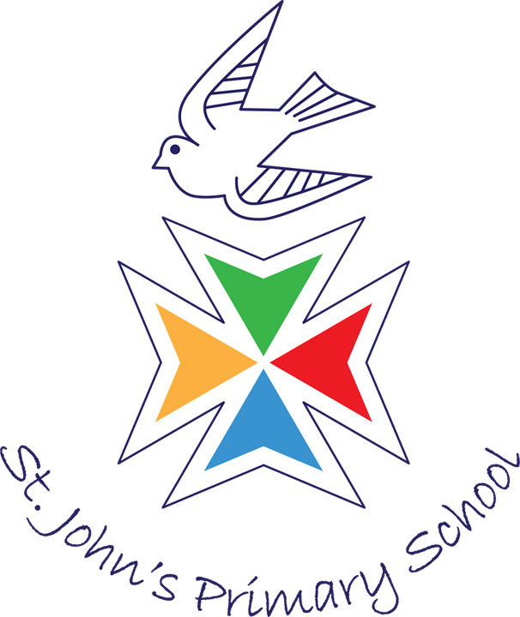
Kingsmill Road, Basingstoke RG21 3JU
Telephone: (01256) 324121
Fax: (01256) 324273
E-mail: adminoffice@st-johnscofe.hants.sch.uk

Headteacher: Mrs A Nicholls
Acting Deputy Head: Mrs A Wynn
Senior Admin Officer: Mrs C Barker

Monday 2nd December 2024

Year 5/6 Visit to QMC

Dear Parents and Carers,

At the start of next term, Year 5/6 are going on a visit to QMC to support their science learning linked to forces.

Mexico class are going on Tuesday 7th January, Poland class on Wednesday 8th January, and Costa Rica class on Friday 10th January. All classes will be leaving school at 1.05pm and returning at 3.00pm.

No permission slip is required for this visit as it is covered by the local walking permission that you signed at the beginning of the academic year.

Can you please make sure your child brings to school a waterproof/warm coat on the day of their visit.

In order to be able to go on this trip, we will need three parent helpers for each class who will also stay and take part in the afternoon activities! If you would like to come and help, and have an up-to-date DBS certificate with us, please can you let the school office know as soon as possible.

Thank you for your continued support.

Yours sincerely

Year 5/6 Team

